Homeopathic treatment of COVID-19 / SARS-CoV-2

Filip DEGROOTE, M.D. – 01/05/2020 www.filip.degroote.be

Summary: In this article I want to explain a very successful approach, by analogy with the way I have treated flu the past twinty years, to treat the Covid-19 epidemic by the help of the application of the Energetic Examination (E.E.).
Since the outbreak of the epidemic I’m noticing a very high sensitivity in people (of about 70% ) related to the energy resonance of the Covid-19 virus. This is in sharp contrast with the built-up group immunity which, even after many weeks of the present epidemic, keeps staying very low (3%).
So the energetic virulence is extremely high and that’s why the isopathic remedy is indicated in a very large number preventively and in all cases curatively!
This treatment of Covid-19 has to be built in the first place on the ‘individual remedy’ of the patient (supplemented by the ancestral correction mostly by administering Psorinum), verified by the E.E. Then, further application of the E.E. reveals in most of the cases the need of the isopathic nosode, which will help to accelerate a total healing during the first stages of the epidemic.
When confronted with a hospitalised patient in the last stage, a more clinical approach can be considered.

Introduction:

Coronaviruses:

Coronaviruses are a group of related viruses that cause diseases in mammals and birds. In humans, coronaviruses cause respiratory tract infections that can range from mild to lethal. Mild illnesses include some cases of the common cold (which has other possible causes, predominantly rhinoviruses) especially in winter and early spring, while more lethal varieties can cause SARS, MERS and COVID-19.
Symptoms in other species vary: in chickens, they cause an upper respiratory tract disease, while in cows and pigs they cause diarrhea.

Of the more than 30 strains of the coronavirus isolated in the laboratory, there are seven variants that can infect humans:
- HCoV-229E
- HCoV-OC43
- SARS-CoV
- HCoV-NL63
- HKU1-nCoV
- MERS-CoV
- SARS-CoV-2 or Covid-19, also called Wuhan-virus, which caused in 2020 the Corona-panepidemic.
SARS, MERS and SARS-CoV-2 can cause lethal lung infections.

Covid-19 / SARS-CoV-2:
The genetic material of Covid-19 consists of a positive single stranded RNA. Covid-19 has barely 15 genes and 27 proteins, while humans have about 25,000 genes and 20,000 proteins. And yet the new coronavirus - a billionth of a meter in size - manages to bring our entire society to a halt.

Types:
- A-variant: Wuhan (China) – source: can bats -- USA
- B-variant: Azia (low virulence towards European people)
- C-variant: in Europe coming from Singapore, Hongkong and South Korea

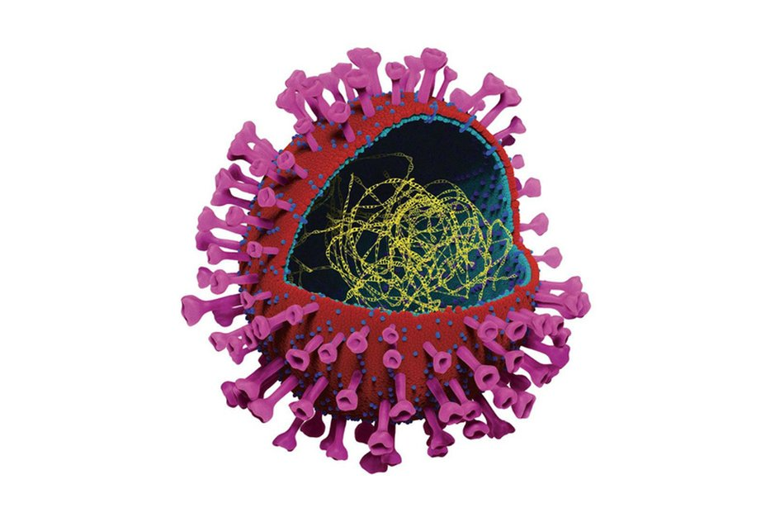

High risk population :
- Eldery people (men more than women)
- People suffering from chronic diseases
- Obesitas
- ….
- People having blood type A = risk is 20% higher (in contrast with blood type O which is much less sensitive).
- An elevated ferritine level seems having a link to the possibility of developing the ‘cytokine release / storm syndrome’.
- ….

The viral survival an contamination:
The infectious amount decreases by half after 3 hours. Researchers have reached this conclusion by determining the TCID50 (Tissue Culture Infectious Dose), the dose that decreases a given concentration of target cells by 50% due to a cytopathogenic effect. Based on this, viability was estimated at 24 hours on cardboard and 2-3 days on plastic and stainless steel.
The Sars-CoV-2 could not longer be detected on printing paper and tissues after 3 hours and on wood and tissue after 2 days. The virus was detected the longest on smooth surfaces such as glass (4 days) and plastic and stainless steel (7 days). After 7 days, the virus could still be found on the outside of surgical masks (approximately 0.1% of the original inoculum).
Other studies suggest that the estimated median half-life of SARS-CoV-2 was approximately 5.6 hours on stainless steel and 6.8 hours on plastic. (Dr. van Doremalen, Mr. Bushmaker, and Mr. Morris; NEJM.org , March 17, 2020)
Last information: The estimated viability on cupper is 4 hours, 24 hours on cardboard, and 2 à 3 days on plastic and stainless steel. The survival on clothing seems to be very limited.(Domus Medica, Belgium, 29/04/2020)
Some recent studies suggest that patiënts can continue to secrete SARS-CoV-2 virus up to 6 weeks after the first symptoms started.

Diagnosis :
RT- PCR-test
SARS CoV-2 IgM and IgG antibodies test
CT-scan thorax
THE HOMEOPATHIC TREATMENT DURING THE DIFFERENT STAGES OF THE DISEASE

1. PREVENTION:
a. Administration of the individual remedy of the patient, if indications are present!
This makes the patient ready to defend him/herself.

b. ? Administering a preventive remedy?
Cf. Oxillococcinum or influenzinum in case of flu.
The preventive administration of such a nosode is not justified if not confirmed by Energetic Testing.
Moreover, by administering a wrong remedy the energy of the patient disrupts and weakens instead of strenghtening.

2. ACUTE (curative) :

Symptoms and course of the disease:
I. Incubation time: Symptoms develop about 2 à 14 days after viral exposure.
The highest virulence is about 3 days before the first symptoms apper and the first days of the acute phase. During those first days, still before the onset of the first symptoms, the infection is already passed on through the normal contacts, so without being aware of it.
Only 10% of the patients tested positive develop flu symptoms, including fever, myalgia, ...

II. Mild symptoms (dry cough and fever).
(1.) At first it is like an ordinary flu. Fever (90%), dry cough (70%) and fatigue (40%). Rarely diarrhea, little myalgia, throatache and headache. = ‘First stage’.
In 30% one of the first symptoms is a loss of smell and taste!
(2.) After a week one often feels healed and even very fine during about 2 days. (! Feels well before going worse) = ‘Second stage’.

III. Possible evolution to a ‘Third stage’: dyspnoe / pneumonia / ARDS (acute respiratory distress syndrome or shocklung).
(3.) The dry cough persists and the patient becomes quicly short of breath, which requires admission to a hospital (IC unit).
It feels like there is a brick lying on the chest or a band around the chest, as if the lungs are no longer able to fill completely.

Severe lung damage occurs in about 20% of patients admitted to hospital (ICU). This is attributed to an excessive production of cytokines, a hyper-immune response that can even lead to a cytokine storm syndrome.
On CT scan it is seen that the alveoli at the level of the lung base are filled with pus and fuse so that hepatisation of the lung develops.

Afterwards (after leaving the hospital), patients may remain contagious for approximately 14 days (or more) and therefore have to remain quarantined at home for another 2 weeks.
General rehabilitation (of muscles, heart and lungs) after intubation / ventilation is an average of 1 week or more per day of intubation, depending from the age of the patient, … .

UNIQUE PLACE IN THE TREATMENT OF Covid-19 BY ISOPATHY:

Covid-19 remedy : radionic code rate = 894835
Covid-19 nosode available from homeopathic companies:
- Gudjons pharmacy, Germany
It’s called sputum. To order, order “Sputum” (as they can’t name it Corona officially, too risky in public).
Friedrich-Merz-Straße 1, 86153 Augsburg, Duitsland - +49 821 4447888 ; labor@gudjons.com

- Farmacy Sollie (Antwerp) +3232374556 : made of the sputum of a Covid-19 positive woman.

1. Energetic testing reveals the following energetic imbalance:

Hypotony of the right m. supraspinatus little finger upward
Hypotony of the left m. latissimus dorsi
Hypotony of the left m. gluteus medius
Hypotony of the right m. soleus
Hypotony of the right m. quadriceps femoris

There is also a Therapy Localisation at the Acupuncture point Lung 2, left.

(With Eyes Closed there is a hypotony of the right m. latissimus dorsi)

2. The prescription approach is like I treat flu as well preventively as curatively:
See: www.flilip.degroote : Publications, ‘Influenza and sycosis’

a. First the individual remedy, followed by (usually) Psorinum.

b. Then:
- Let the patient close the eyes for about 5 seconds. Then mostly, if the nosode is indicated the energetic picture will appear.
- In case it doesn’t appear, then try a glabella tapping with eyes open (without winking). Then sometimes the energetic picture of Covid-19 at last appear.

So, if the nosode Covid-19 becomes indicated, the muscle tests will appear!
Then of course administer the nosode.

(If you a radionic machine to your disposition the current dose is mostly MK, with can be directly administered via the right thumb.)

NB: Do not blindly administer preventively this isopathic nosode !!

SCHEDULE OF THERAPY

Stage 1:
Cough, fever, pain in muscles and joints, coryza, loss of smell and taste, headache, nose obstruction, sinusitis, nausea, weakness, restless, anxiety, ..

- Suggested remedies in de literature: bry., gels. (= anti-flu remedies – Vithoulkas), ant-ars., ant-t., ascl-t., eup-per., merc., phos., ph-ac., …
- MY APPROACH:
First the individual remedy of the patient , based on peculiar symptoms and dreams originating from before the Covid-19 disease, followed by (usually) Psorinum, and then – moslty confirmed by the Energetic Examination – the isopathic Covid-19 nosode.

Stage 2: (INTERMEZZO) : the patient feels well

MY APPROACH:
First the individual remedy of the patient , based on peculiar symptoms and dreams originating from before the Covid-19 disease, followed by (usually) Psorinum, and then – mostly confirmed by the Energetic Examination – the isopathic Covid-19 nosode.

Stage 3:
Severe pneumonia, myocarditis, pericarditis, ...
… day 10: cytokine storm syndrome leading to ARDS and multiorgan failure.

Probably important symptoms to be taken into account:
‘Respiration, difficult, lying on abdomen amel.’
Only to find in the rubric: Generalities, Lying on abdomen amel.
(Also similar: Respiration: difficult, lying on back agg.; lying on back agg.)

Feels well before going worse

The following remedies, mostly selected on clinical symptoms, score the best: (acon.), ant-ars., ant-t., ars., ars-i., ascl-t., bell., bry., (calc-p.), chel., hep., iod., kali-c., kali-i., (lyc.), nit-ac., nux-v., ph-ac., phos., psor., stann., sulph. (californium, pyrogenium, radon, … )

NB: Relation ‘Acon. – Sulph.’: I want to remind you of the relation between the acute remedy Aconitum and its chronic remedy Sulphur, in the way Kent reports:
Kent: Lesser Writings, page 506:
' A case of pneumonia that has reached to the stage of exudation and where the patient is in a state of mental anxiety. You find Aconitum to be indicated, but as sure as you give it you will fail. When I first commenced prescribing I gave Aconite and I never had anything but failure. Give Sulphur at once and you will cure the patient. I say in ninety-nine cases out of one hundred give Sulphur! '

EXAMPLES (own cases with mild symptoms) :

1. A little boy of 15 months old has fever and cries violently, and even more when the mother tries to console him. On the other hand he calms while putting a cold hand on his left ear.
Clinical examination reveals a left otitis media and cold hands during fever.
A remarkable symptom to me was that the mother told me that he had during the last weeks in the evening frequent copious stools.
So, Aurum metallicum was found:

So I administered him Aur. (supplemented with Psorinum). Then after keeping his eyes closed during a few seconds the energetic picture of Covid-19 appeared and so Covid-19 MK could be administered.
The little boy recovered soon and is still OK!
2. A man of 72 years old, suffering from recurrent colds, came with a sudden upset of cough and dyspnoea. Also he had throatache on swallowing, as if grasped with a hand around the throat, impending him to breathe.
He also had several times a stitching pain at height of the left parasternal intercostal space.

He could tell me also two dreams:
In the first dream he and his wife were making a walk. At a certain place his wife notices acquaintances in a feast hall and wanted to greet them. While she entered he waited outside and was distracted by a silly jumping cat-like animal so that they missed each other and each of them returned home separately.
In another dream he notices that the waist belt a man wears is actually a snake!

Lachesis is the simillimum!

Symptoms and themes:
Throat, Constriction, as if grasped by a hand
Pain, 4° intercostal space, parasternal, left (= an energetic painful point – Pladys , A.)

Snake themes:
Dream, Splitted up (as result of being distracted)
Dreams, Waist belt is a snake

So I administered him Lachesis (supplemented with Psorinum). Then after keeping his eyes closed during a few seconds the energetic picture of Covid-19 appeared and so Covid-19 MK could be administered too.
He became soon better with disappearance of all the symptoms.

Note: Sources concerning the Energetic Examination (www.filipdegroote.be):
Physical Examination and Clinical Observations in Homeopathy, F. Degroote (1992 – revised and updated electronic edition 2014 - Radar Opus)
Notes on Miasms and Heredity, Filip Degroote (1° edition: 1994 / 2° edition: 2010)
Energetic Pictures, Filip Degroote, 2019 - Radar Opus
(WRONG) SEARCH FOR A GENUS EPIDEMICUS

- My convinction:
There is not ‘one ’genus epidemicus. This conclusion is in analogy with my experience of the yearly flu-epidemic I have already since more than 20 years.
The most important remedy during the first and second stage of the disease is the individual remedy of the patient which can act in 90% of the cases as well preventively as curatively, followed mostly by Psorinum (as ancestral correction)!
Then often the energetic indication to administer the isopathic Covid-19 remedy is found!

Since the outbreak of the Covid epidemic I found in about 70% of the cases ’with or without covid symptoms’ that besides the individual remedy and the nosode (mostly Psorinum) the Covid-19 isopathic nosode must be supplementary administered. The healing effect in all cases was complete!

Further on, I guess that during the third stage, which is a very severe stage during which hospitalisation is mostly necessary, about ten % of the cases need supplementary an acute remedy or a remedy in relation with this severe pathology.
To be followed afterwards, once better and when left that third stage, by a deep individual treatment – cf. stage 1 and 2.

- This third stage, which is a ‘pathological’ state, is the stage on which most of my fellow homeopaths now are focused to find one of the ‘Covid-19 genus epidemicus’ remedies, based on especially clinical symptoms.

Example:
Report from P. Debaets / J. Sherr (20/04/2020) concerning the treatment of Covid-19 and the search for a genus epidemicus:

- AMMONIUM CARBONICUM
- PHOSPHORUS
- BERYLLIUM METALLICUM
- CUPRUM

Nosodes, related
- TUBERCULINUM AVIS
- YERSINIAE SERUM (YERSINIA ENTEROCOLITICA)

Remedies related to classical drugs
- ANISUM STELLATUM (related to Tamiflu®)
- CHINA (cf. hydrochloroquine, an anti-malaria remedy)

